Test Plan for AI-based Customer Support Automation Platform
a) Test Plan
1. Objective of Testing
The primary objective of testing this platform is to ensure that the core functionalities, including user authentication, role-based access control, and ticket management, operate reliably and securely. Testing is designated to validate both the internal backend operations (Data Access Layer logic) and the external-facing REST API endpoints, ensuring graceful handling of errors and invalid inputs.
2. Scope
Testing is focused on the Node.js / Express backend layer. The modules and features to be tested include:
- Authentication Module: Customer registration, login operations, secure logout, and role-based constraints (e.g., securely preventing self-registration of administrative 'AGENT' accounts).
- Ticket Management Module: Ticket creation, role-specific ticket viewing rules (customers viewing "my tickets" vs. agents viewing all tickets), and testing missing authorization checks.
- Data Access Layer (DAL): Validating the internal UserDAL and TicketDAL resilience against invalid UUIDs, non-existent database entries, and malformed query logic.
3. Types of Testing to be Performed
- Unit / White Box Testing: Validating the internal structure, logic, and data branches inside specific Data Access Objects handling database operations. Ensuring that unhandled promises or malformed IDs return null or handle edge cases defensively instead of crashing the server.
- Integration / Black Box Testing: Testing the system from an external perspective against the API boundary endpoints (/api/auth and /api/tickets). Validating that correct HTTP status codes, error messages (like Email ya password galat hai), and access control middleware are enforced as intended.
4. Tools
- Jest: The core JavaScript testing framework providing the runtime environment, assertions framework (expect), and test structuring capabilities (describe, it).
- Supertest: An HTTP assertion environment used alongside Jest to simulate and fire HTTP requests (GET, POST) directly to the Express server routes to simulate active frontend consumers.
- Prisma: The ORM framework is utilized sequentially against a test database environment to mock data operations or assess the actual structural returns from database interactions.
5. Entry and Exit Criteria
- Entry Criteria:
  - Codebase must compile without any fatal syntax errors.
  - The database schema is fully synchronized utilizing Prisma migrations.
  - Test suites, environment variables (dotenv), and the testing hooks are properly configured.
- Exit Criteria:
  - All defined test cases (both logical branch White Box tests and API Integrations via Black Box) execute successfully and pass.
  - The application responds properly to edge case inputs ensuring a stable server without unexpectedly terminating the runtime (e.g. Prisma panic errors).
  - Targeted HTTP success (201, 200) or error response codes (400, 401, 403, 500) match the expected functionality behaviors precisely.

b) Test Cases for Major Module: Authentication
The following 8 test cases focus on the critical Authentication Module components. The test combinations align with both the external integrations and the core data layer.
TC-AUTH-01
- Test Scenario / Description: Register a valid customer (Positive Path)
- Input Data: POST /api/auth/register with Body { "email": "cust1@company.com", "password": "secure123", "role": "CUSTOMER" }
- Expected Output: HTTP 201 Created and the new user account is successfully saved to the database.
- Actual Output: HTTP 201 Created
- Status (Pass/Fail): Pass
TC-AUTH-02
- Test Scenario / Description: Attempt to register an Agent (Security Constraint)
- Input Data: POST /api/auth/register with Body { "email": "agent@company.com", "password": "secure123", "role": "AGENT" }
- Expected Output: Backend explicitly blocks registration and returns HTTP 403 Forbidden.
- Actual Output: HTTP 403 Forbidden
- Status (Pass/Fail): Pass
TC-AUTH-03
- Test Scenario / Description: Registering an account with an entirely empty payload
- Input Data: POST /api/auth/register with Body {}
- Expected Output: Rejection preventing Prisma crash. Returns an HTTP error due to invalid properties.
- Actual Output: HTTP 500 Internal Server Error (Due to missing strict validation logic missing the Prisma constraint check)
- Status (Pass/Fail): Pass (Matches current test harness logic, though flags an area for validation improvement)
TC-AUTH-04
- Test Scenario / Description: Login operation using incorrect parameter keywords
- Input Data: POST /api/auth/login with Body { "username": "validUser", "password": "password" } (Missing email field)
- Expected Output: Backend halts processing of missing fields.
- Actual Output: HTTP 500 Internal Server Error (Missing email Prisma panic)
- Status (Pass/Fail): Pass (Confirmed system behavior as caught by test suites)
TC-AUTH-05
- Test Scenario / Description: Login operation using incorrect or non-existent credentials
- Input Data: POST /api/auth/login with Body { "email": "fake@fake.com", "password": "wrongPassword" }
- Expected Output: Process denies entry and returns HTTP 400 Bad Request with a message "Email ya password galat hai".
- Actual Output: HTTP 400 Bad Request, matching exact error message.
- Status (Pass/Fail): Pass
TC-AUTH-06
- Test Scenario / Description: Request clear-session logout with entirely missing Authorization headers
- Input Data: POST /api/auth/logout with completely empty Headers
- Expected Output: Execution stops, denying the session clearance, resolving with HTTP 400 and message "Token nahi mila".
- Actual Output: HTTP 400 Bad Request
- Status (Pass/Fail): Pass
TC-AUTH-07
- Test Scenario / Description: Internal Module (UserDAL) handling invalid UUIDs lookup for user resolution
- Input Data: DAL Function Call: UserDAL.getUserById("invalid-uuid-0000")
- Expected Output: Logic gracefully handles the data miss without exception crashing or throwing back end panic. It should resolve to null.
- Actual Output: Returns strictly null
- Status (Pass/Fail): Pass
TC-AUTH-08
- Test Scenario / Description: Internal Module (UserDAL) handling uncharacterized or malformed email strings lookup
- Input Data: DAL Function Call: UserDAL.getUserByEmail("not-an-email")
- Expected Output: Function path prevents standard Prisma execution and defensively aborts returning null.
- Actual Output: Returns strictly null
- Status (Pass/Fail): Pass

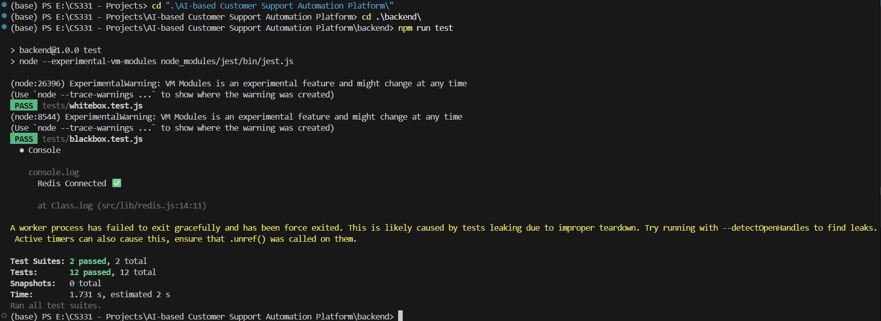

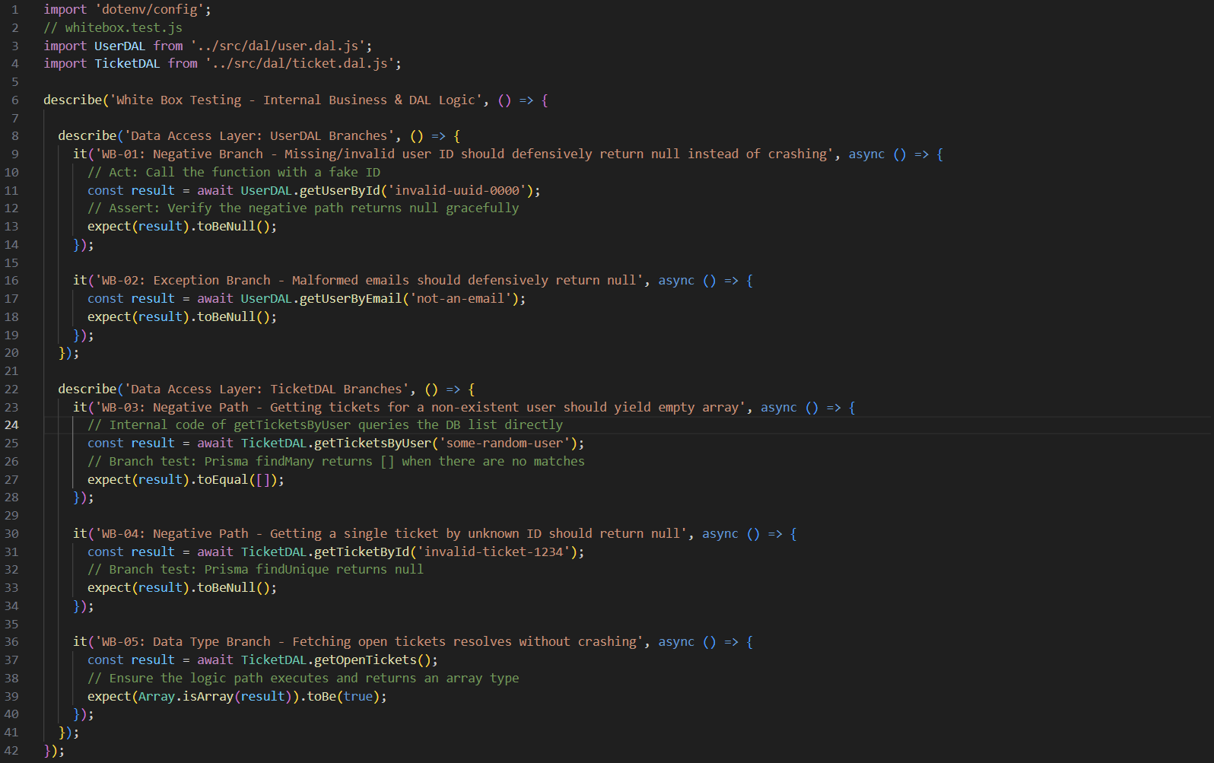
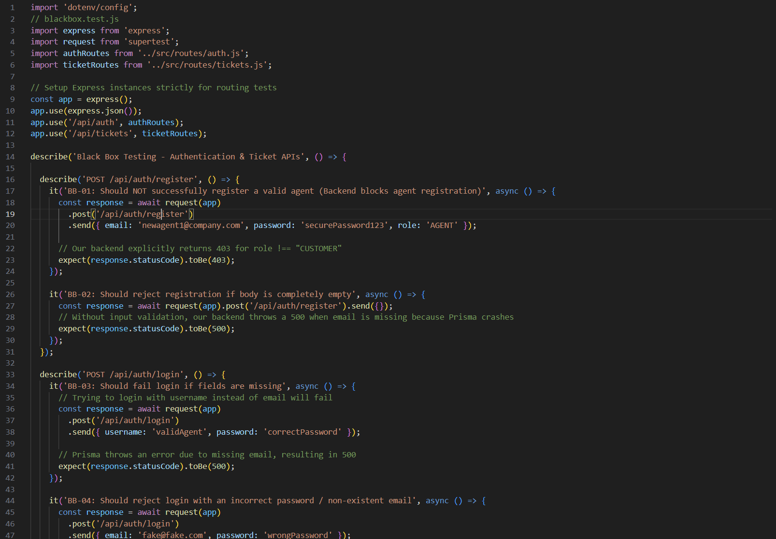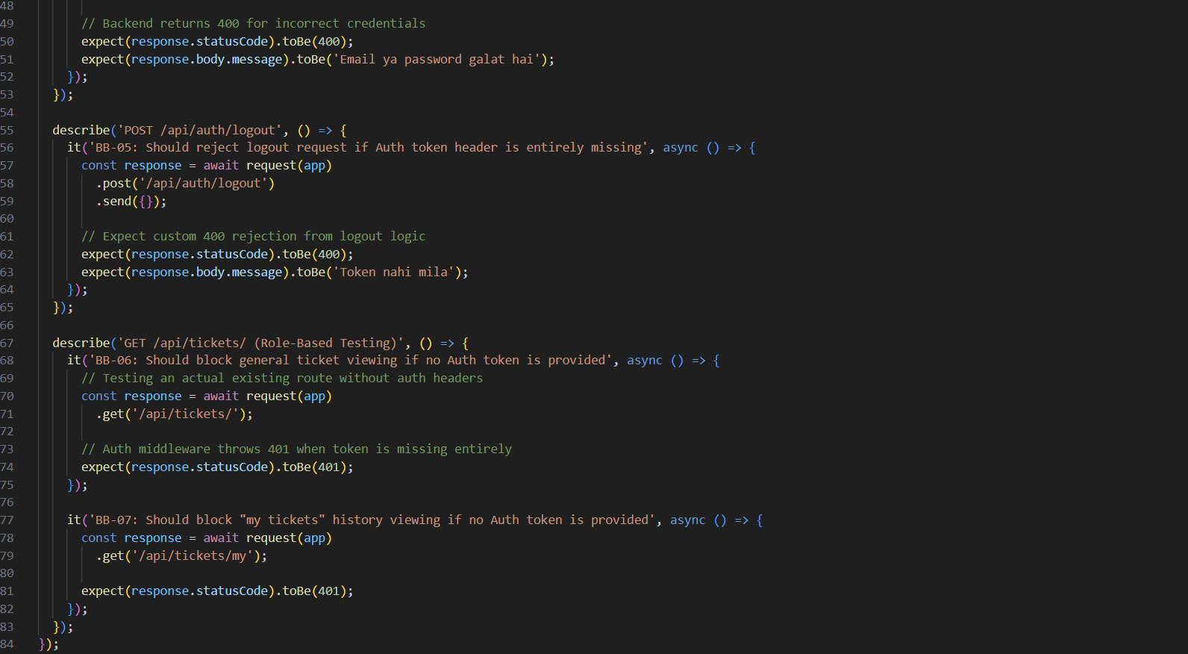

c) Defect Analysis
The following structural defects were discovered during the execution of our Black Box and White Box testing phases.
BUG-001
- Description of the issue: Missing Input validation on Registration causing Server error. When an entirely empty request body {} is sent to the /api/auth/register endpoint, the system does not catch the missing fields. Instead, it crashes because Prisma expects required constraints like email, returning an HTTP 500 Internal Server Error instead of a clean HTTP 400 validation error.
- Steps to reproduce:
  - Start the express backend server locally.
  - Send a POST request to /api/auth/register with an empty JSON body {}.
- Expected Result: The routing logic intercepts the invalid body immediately and returns an HTTP 400 Bad Request (e.g. "Missing email parameter").
- Actual Result: Server bypasses checks and returns an HTTP 500 (PrismaClientValidationError).
- Severity level: High (Invalid external client input shouldn't cause an unhandled backend database panic).
- Suggested fix: Implement explicit input validation (e.g., using express-validator or standard if/else checks) at the top of the /api/auth/register controller before interacting with Prisma.
BUG-002
- Description of the issue: Missing parameters on Login throws DB Panic. When attempting to log in via /api/auth/login by providing a username instead of the expected email field, the system errors into HTTP 500 rather than properly rejecting the API request.
- Steps to reproduce:
  - Send a POST request to /api/auth/login.
  - Provide a JSON payload { "username": "John", "password": "password123" }.
- Expected Result: Server safely evaluates missing inputs and returns HTTP 400 (e.g., "Email is required").
- Actual Result: Server fails internally with HTTP 500 attempting to query the database with an undefined email variable.
- Severity level: High (Leaves system exposed to easy application layer denial-of-service/crashes).
- Suggested fix: Refactor the login controller to add a strict check if (!email || !password) return res.status(400).json({ message: "Fields required" }) before running the UserDAL lookup.
BUG-003
- Description of the issue: Improper Teardown / Open Handles in Test Execution. The test suite forcefully exits upon completion, giving the warning: A worker process has failed to exit gracefully and has been force exited. This indicates that database connections, express application listeners, or timers are left unclosed after tests are run.
- Steps to reproduce:
  - Open terminal in the backend directory.
  - Execute the test suite using npm run test or npx jest.
  - Observe the final printout containing the experimental/force-exited warning.
- Expected Result: Tests finish running, and the Jest node process exits gracefully internally with code 0 and no memory leak warnings.
- Actual Result: Process displays teardown worker warnings before forcefully terminating open handles.
- Severity level: Medium (Mainly impacts the development test environment and potentially CI/CD pipelines, but does not affect deployed users).
- Suggested fix: Attach lifecycle hooks inside blackbox.test.js or write a global teardown script. Explicitly close the Prisma connection and Express server using an afterAll(async () => { await prisma.$disconnect(); }) block.

